**1. Introduction to Project Definition**

**Face Recognition System**

* In this Project we create Face Recognition System in cpp.

**2**. **PREAMBLE**

* In this project we use Opencv & Iostream Library .
* In this project it make on Machine learning & Computer Vision.
* So for that we have to use A pre-trained Weigh “haarcascade_frontalface_default.xml”.

**3**. **STUDY OF EXISTING SYSTEM**

**There are mainly 4 types of algorithms**

1. Haar Cascade Face Detector in OpenCV.

2. Deep Learning based Face Detector in OpenCV.

3. HoG Face Detector in Dlib.

4. Deep Learning based Face Detector in Dlib.

* In this Project we use Haar Cascade Face Detector In opencv algorithm .
* because it’s work almost real-time on cpu , and simple architecture is there also.
* It can detects face at different scale .

**4. TECHNICAL DESCRIPTION**

**4.1 Hardware Requirement**

* A system must or higher than i5 10th gen and must 8 gb ram .
* A good quality inbuilt or portal webcam for camera use.
* A internet access.

**4.2 Software Requirement**

* Opencv (library) 4.55 or latest version.
* Visual Studio (IDE) 2019 or latest version.

**5. SYSTEM DESIGN AND DEVELOPMENT**

**5.1 Flowchart**

1. First we take each frame from video.
2. After making frame using haar cascade algorithm we get a per frame a pipelines on frame.
3. After all frames get ready make a video with all frames pipeline.

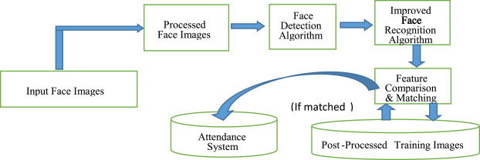

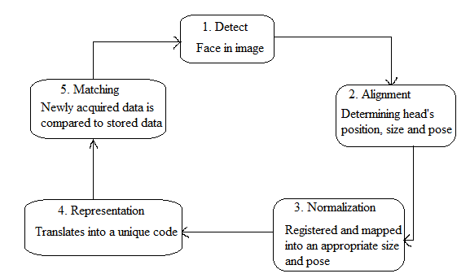

**6. CONCLUSION**

* In this topic face detection is a part of machine learning and also computer vision, so a face recognition throw we can it make worth it in health, banking, security sectors.
* Face recognition technology has come a long way in the last twenty years. Today, machines are able to automatically verify identity information for secure transactions, for surveillance and security tasks, and for access control to buildings etc. These applications usually work in controlled environments and recognition algorithms can take advantage of the environmental constraints to obtain high recognition accuracy. However, next generation face recognition systems are going to have widespread application in smart environments -- where computers and machines are more like helpful assistants.

**7.** **LEARNING DURING PROJECT WORK**

* We learn visual studio functionality and how to make and handle intermediate project like face recognition system.
* We learn opencv library for a specific face detection algorithms.
* Also a little bit a machine learning part for pre trained weight.

**7.1 Future Enhancement**

* To improve a time complexity and a accuracy of algorithm and new specifics weight for detection.
* We also get a attention module using face detection.

**8. BIBLIOGRAPHY**

**8.1 Online References**

* <https://www.geeksforgeeks.org/opencv-c-program-face-detection/>
* <https://docs.opencv.org/2.4/modules/contrib/doc/facerec/facerec_tutorial.html>
* <https://docs.opencv.org/2.4/doc/tutorials/objdetect/cascade_classifier/cascade_classifier.html>